

Applied machine learning
On
Face emotion sytem
Submitted by -

Name | SAP ID | Email | Specialization
Prashant gaur | 590016056 | PRASHANT.16056@stu.upes.ac.in | AIML
Mradul goyal | 590016200 | MRADUL.16200@stu.upes.ac.in | AIML
Amit raj | 590013887 | Amit.13887@stu.upes.ac.in | AIML
for the academic session 2025-2026.

Date: 27-04-2026
Project Mentor
Santosh panda
Assistant professor
SoCS, UPES

title
facial emotion detection system using machine learning

abstract
this project is about building a system that can detect human emotions from facial expressions using machine learning. the system takes input either from images or live webcam and predicts the emotion shown on the face.
the project mainly includes dataset handling, training a model, saving model weights, and creating a simple interface for real-time detection. different components like face detection, image preprocessing, and emotion classification are combined together.
the final system works in real time but has some limitations in accuracy depending on conditions like lighting and face angle.

introduction
facial expressions play an important role in communication and understanding human emotions. with the help of artificial intelligence, computers can now analyze faces and predict emotions.
in this project, we developed a facial emotion detection system using basic machine learning techniques. the project was divided into different parts such as data preparation, model training, and system integration.
the system first detects a face using a detection algorithm, then processes the image, and finally uses a trained model to classify the emotion.
this project gives a practical idea of how ai-based systems are built and used in real-world applications.

literature review
earlier systems for emotion detection used basic image processing techniques like haar cascade classifiers for face detection and manual feature extraction. these methods were simple but not very accurate.
with the development of deep learning, especially convolutional neural networks (cnn), better results were achieved. cnn models can automatically learn features from images, which improves accuracy.
datasets like fer2013 are commonly used for training emotion detection models. many modern systems also use real-time detection and are integrated into applications like surveillance, customer analysis, and mental health tracking.
this project uses a simplified version of these approaches to understand the concept.

methodology
the project was implemented step by step by dividing the work into components:

dataset collection
a dataset containing images of faces with different emotions was used. each image is labeled with an emotion like happy, sad, angry, etc.

preprocessing
before training, the images were processed:
- resized to fixed dimensions
- converted to grayscale to reduce complexity
- pixel values normalized
this step helps in improving model performance and reducing training time.

model training
a convolutional neural network (cnn) model was used for training. the model learns patterns from facial features like eyes, mouth, and expressions.
training includes:
- feeding dataset into model
- adjusting weights using backpropagation
- running multiple epochs
after training, the model is able to classify emotions based on input images.

model weights
after training is completed, the model weights are saved into a file. this allows us to reuse the trained model without retraining again and again.

face detection module
opencv haar cascade classifier is used to detect faces in images or video frames. it identifies the region of the face before passing it to the model.

emotion prediction module
the detected face is passed to the trained model which predicts the emotion and returns the result.

user interface / execution
a simple interface is created using python where:
- webcam captures video
- frames are processed
- face is detected
- emotion is predicted
- output is displayed on screen
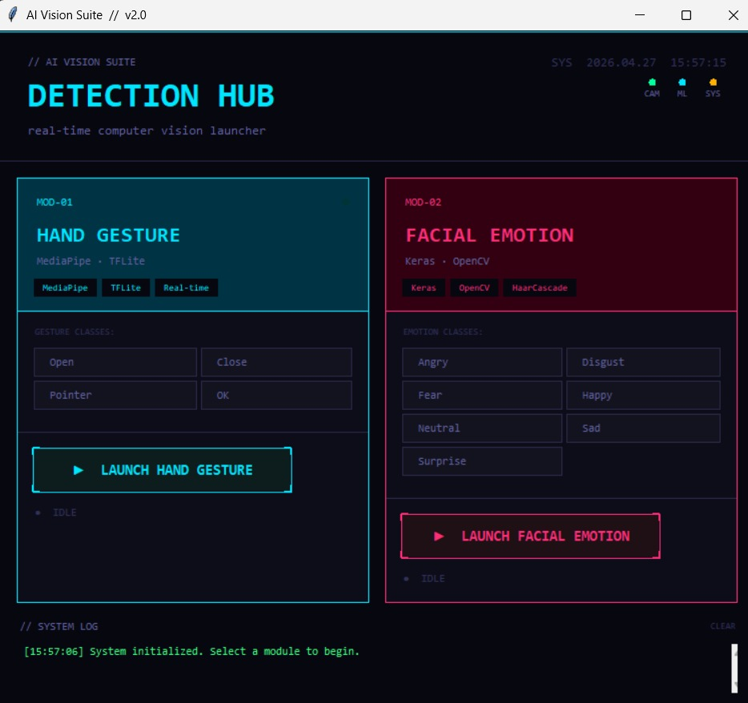
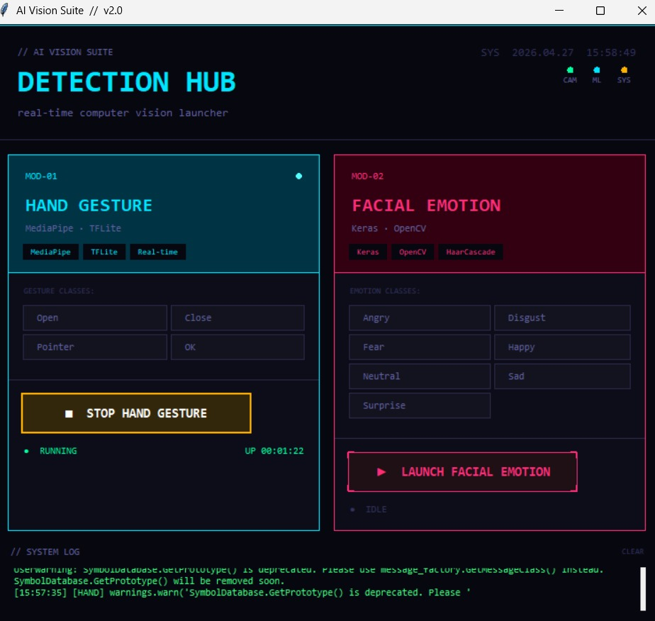
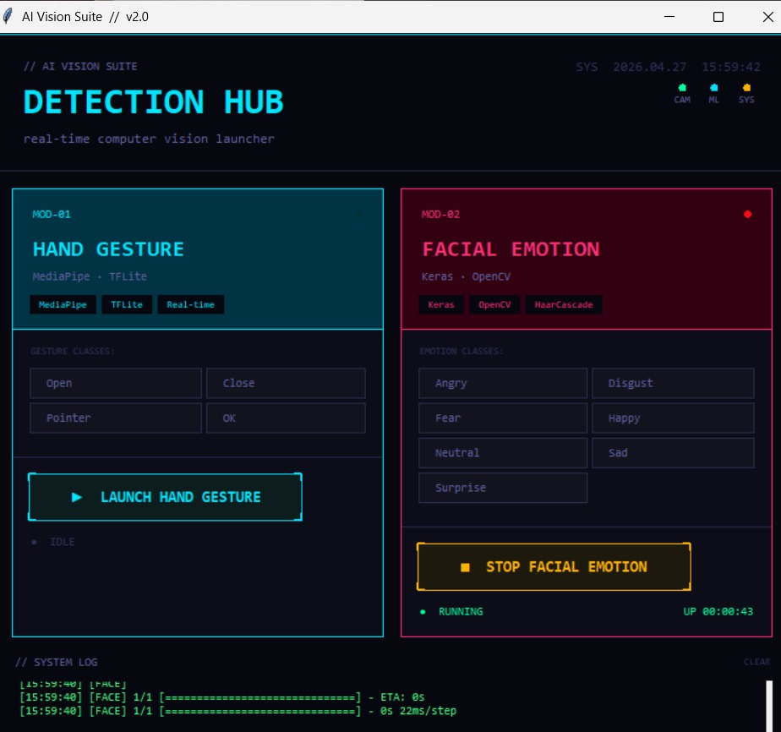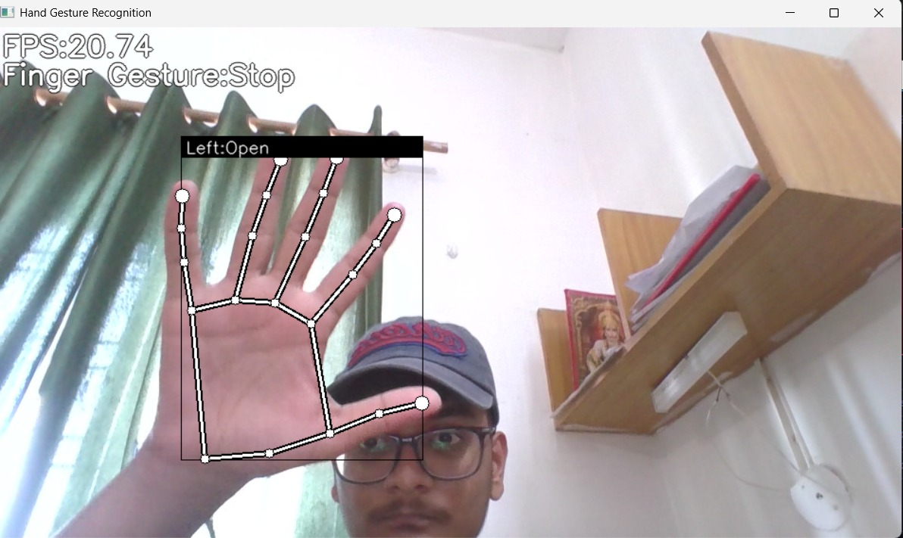
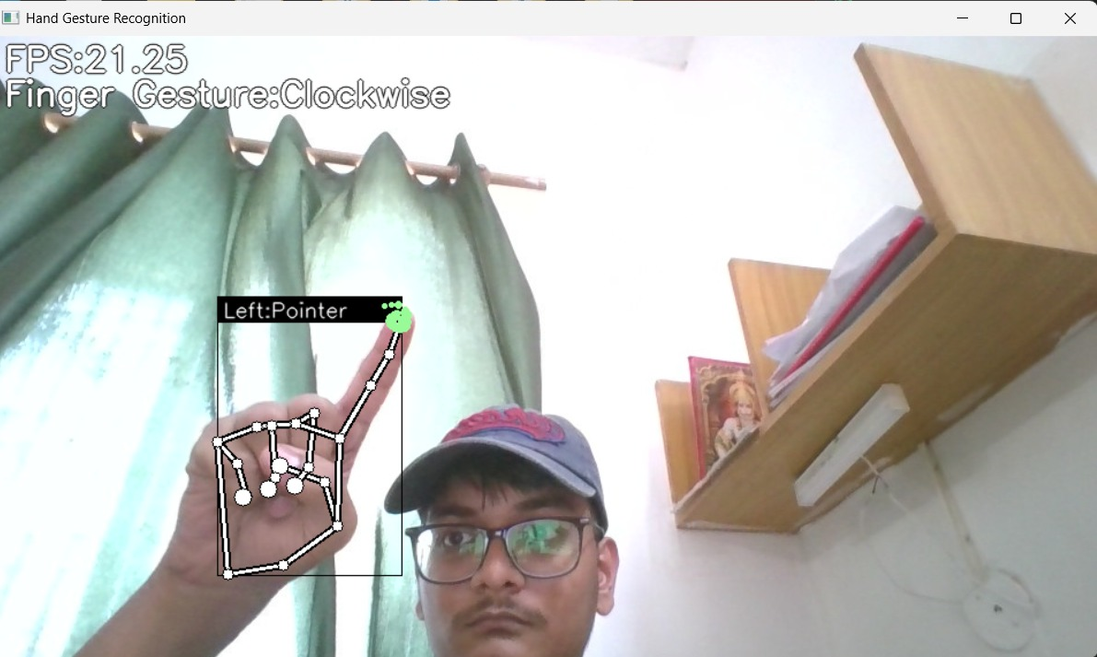


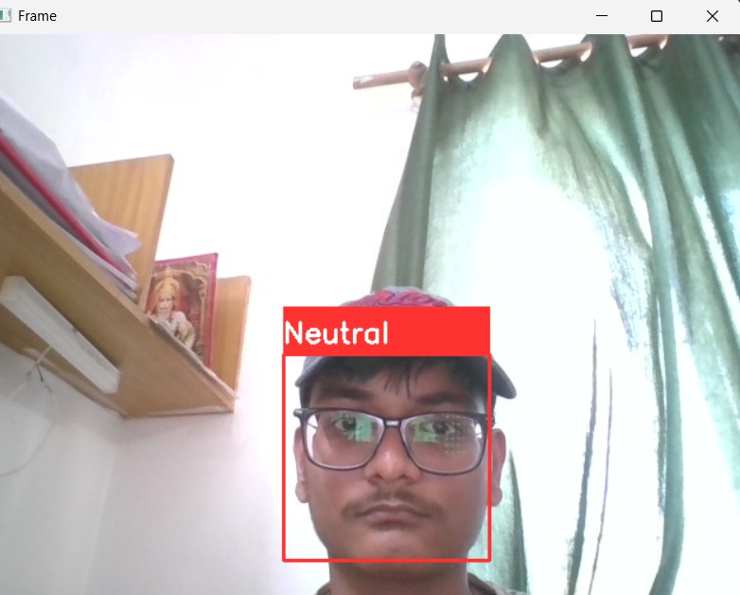


experiment & results
the system was tested using both static images and real-time webcam input.
in good lighting conditions, the model performed reasonably well and correctly detected emotions like happy and neutral.
however, some problems were observed:
- incorrect predictions in low light
- difficulty in detecting side faces
- confusion between similar emotions
accuracy was moderate because the dataset used was limited and the model was not very deep.
overall, the system works but is not highly reliable in all conditions.

conclusion & future work
the project successfully demonstrates a basic facial emotion detection system using machine learning. it shows how different components like preprocessing, model training, and real-time detection work together.
working as a group helped in completing different parts of the system efficiently.
future improvements can include:
- using a larger dataset for better accuracy
- applying advanced deep learning models
- improving face detection techniques
- optimizing real-time performance
- adding more emotion categories
this project can be extended into real-world applications like smart systems and user behavior analysis.

reference
- machine learning and deep learning concepts
- fer2013 dataset
- opencv documentation
- tensorflow / keras documentation
- online tutorials and guides

